# LABORATORY: SOFTWARE ENGINEERING II LAB (R4CO3011P)

**Illustrate the following four experiments with respect to Aim, Objectives and Literature Survey, Implementation, Testing and conclusion.**

**Give the references of 5 research papers of IEEE, ACM and Springer** **of object oriented software engineering for each experiment.**

# Instructor Dr. BANDU B. MESHRAM

================================================================================

**Experiment 1: Write SRS, (Choose Real Life application suggested by Instructor).**

Write SRS .Consider the fact finding techniques: Interviews, Questionnaires, Record Review and Observation for gathering information about object oriented systems. Use SRS format

**Consider Following Functional Requirements.**

**1. Basic Requirements**

* + Fundamental Details Of The System And Information Flow
  + Identify Data Used And Information Produced
  + Determine Process Timing And Volume Of Data To Be Handled
  + Identify Controls : Error Handling And Performance Standards

**2.User Transaction Requirements**

* + What Initiates The Transaction?
  + What Are The Schedules And Serialization Process?
  + Generated Data And Stored Data

**3.User Decision Requirements**

* Information Used To Make The Decision
* Source Of Information-Transactions Or Data Outside The System
* Processing Of Data To Produce Required Output

**4.Organization Wide Requirements and project management**

* Manufacture Products
* Satisfy The Customers
* Cost Benefit Analysis
* Project management-cost, effort, time.

**Consider the following Nonfunctional Requirements** (NFRs **).**

* Usability requirement
* Serviceability requirement
* Manageability requirement • Recoverability requirement
* Security requirement
* Data Integrity requirement
* Capacity requirement
* Availability requirement
* Scalability requirement
* Interoperability requirement
* Reliability requirement
* Maintainability requirement
* Regulatory requirement
* Environmental requirement
* performance

**Experiment 2. OOAD USING UML**

(i) Give structural view and Behavioral view.

(iii) Implement the project and illustrate implementation view.

(iii) Illustrate the environmental view with specifications.

Use the following dimensions for answering your experiment.

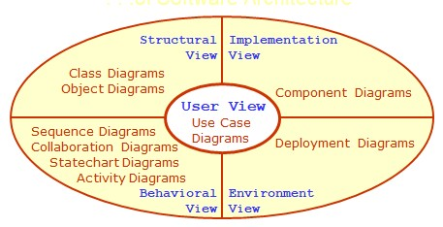

**Map the analysis Model with design Model. Use the following dimensions for the design of object oriented software.**

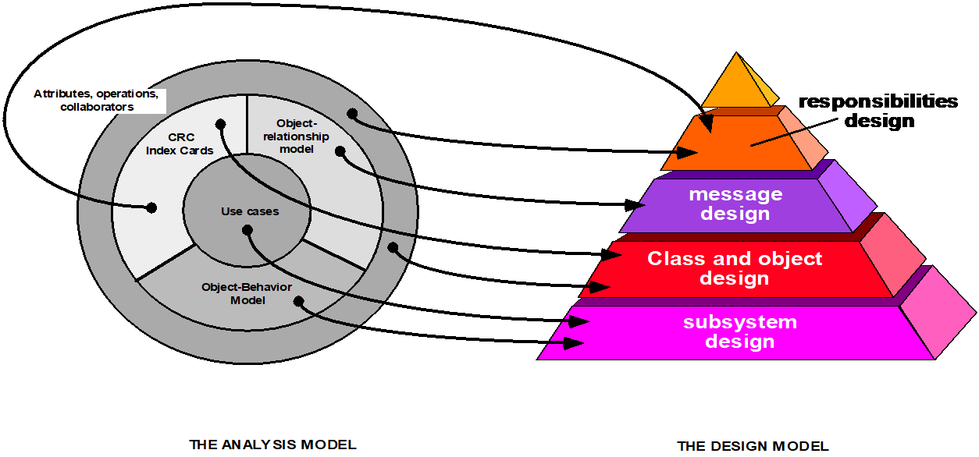

Design the software architecture, algorithm and data structure design and authoring system for the given project.

**=============================================================== Experiment No 3 : Implementation and Reengineering**

1. Illustrate the software project with respect to UP PROCESS given below and implement it using object oriented programming language - C++

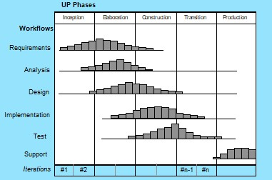

2 Apply following dimensions for Reengineering –(reverse engineering and forward engineering )of object oriented systems . and use the UP Process for iterations or following OO PROCESS MODEL

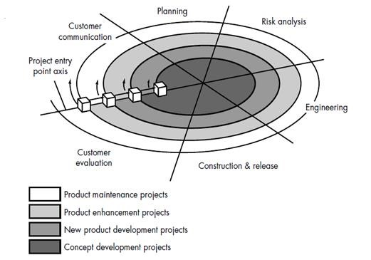

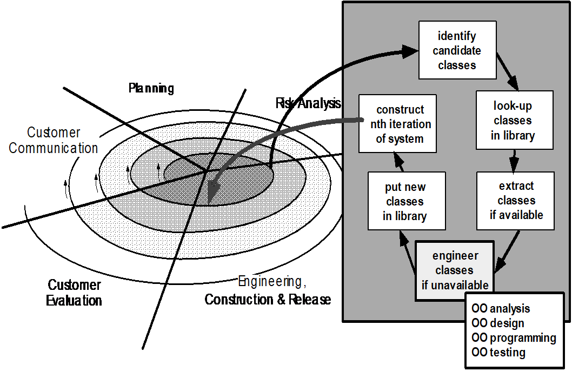

================================================================

**Experiment 3 OO System Testing**

Apply object oriented software testing to test your software. Use the following dimensions for testing

1. Unit Testing 2. Method Testing 3. Class Testing 4. Integration Testing

5. System Testing

You can also use the open source software testing tools, open source functional testing tools, open source web application testing tools, open source performance testing tools, , open source load testing tools, and any other open source testing tools of your choice.

Given below is the list of most popular open source testing tools

Katalon Studio , Selenium , Appium , Robotium ,Cucumber ,Watir , Sikuli

,JMeter ,WatiN ,SoapUI , Capybara ,Tarantula ,Testlink ,Windmill ,TestNG ,

Marathon ,httest , Xmind ,Wiremock ,Maven ,Espresso , FitNesse ,JUnit , Grinder ,Tsung ,Gatling ,Multi-mechanize , Selendroid ,KIF ,iMacros ,Linux Desktop Testing Tool , k6

**================================================================**

**Experiment 4 : Towards Open Application**

1. Build security module and interface it with your project, implement and test it. Show the results to Your Software Engineer Friends. What are the comments/suggestions/opinions given by your friends? Write report of the interviews, questionaries, records and observation.

1. How can you make this application scannable, available and interoperable with other applications? Write a code for it.

Show the results to Your Software Engineer Friends. What are the comments/suggestions/opinions given by your friends? Write report of the interviews, questionaries, records and observation. Lastly show the result to your teacher.

1. Show the results of experiment 4 to your classmates, Discuss the experiment 4 with your classmates and ask their opinion, Write report on it.

========================================================

**The start…**